**Face Recognition Expression – Setup**

**Download Github CLI**

URL : https://cli.github.com/

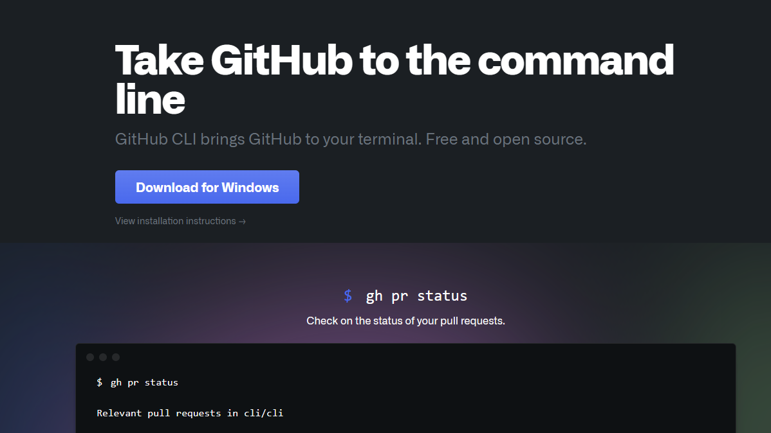

**Download Node JS**

URL : https://nodejs.org/en/download/  
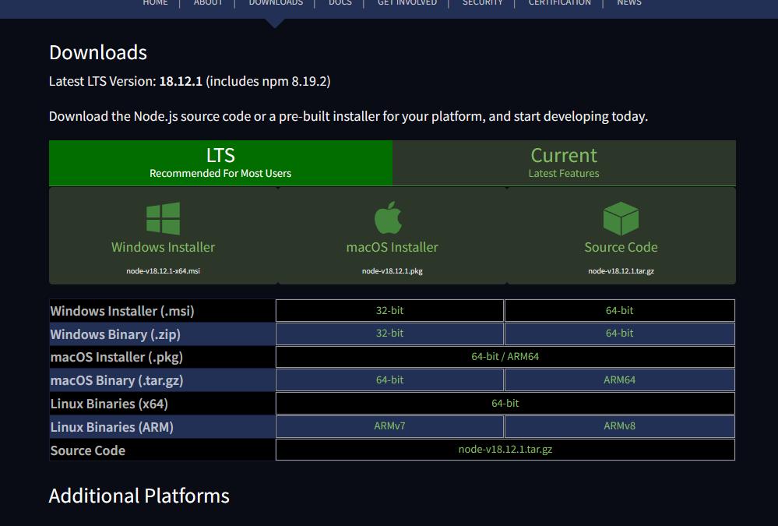

**Clone repository**

git clone <https://github.com/DevPuzon/video-call-face-expression-recognition.git>

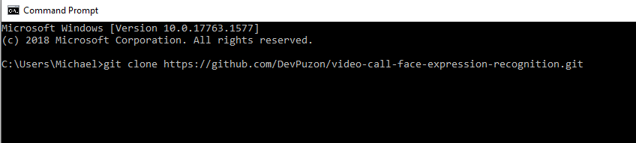

cd video-call-face-expression-recognition

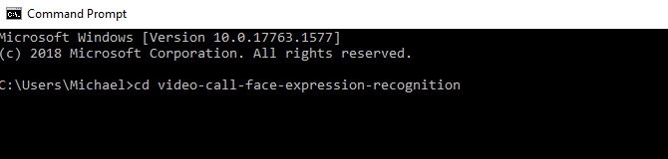

npm i --force

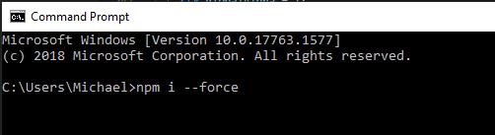

npm run start

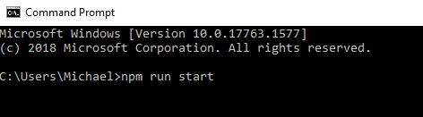 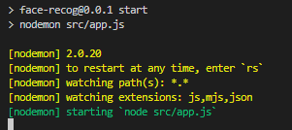

Navigate to browser

URL : <http://localhost:4200/>

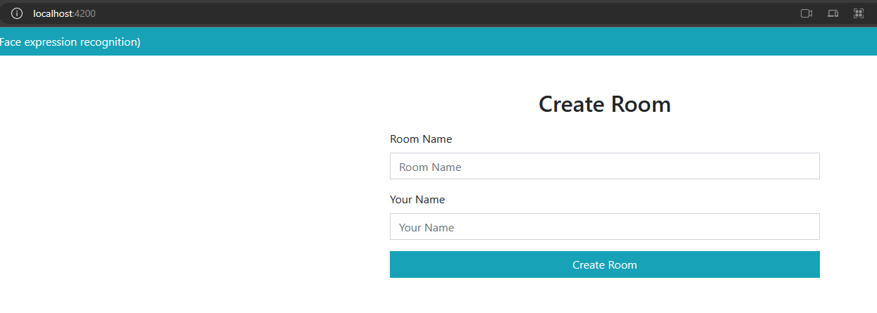  
  
To run the server  
<https://replit.com/@softwaresolutio/video-call-face-expression-recognition>

Run : npm run start  
